NAME : GOWTHAM S
REG.NO: 192565030

15.Write an assembly language program to find the largest number in an array.

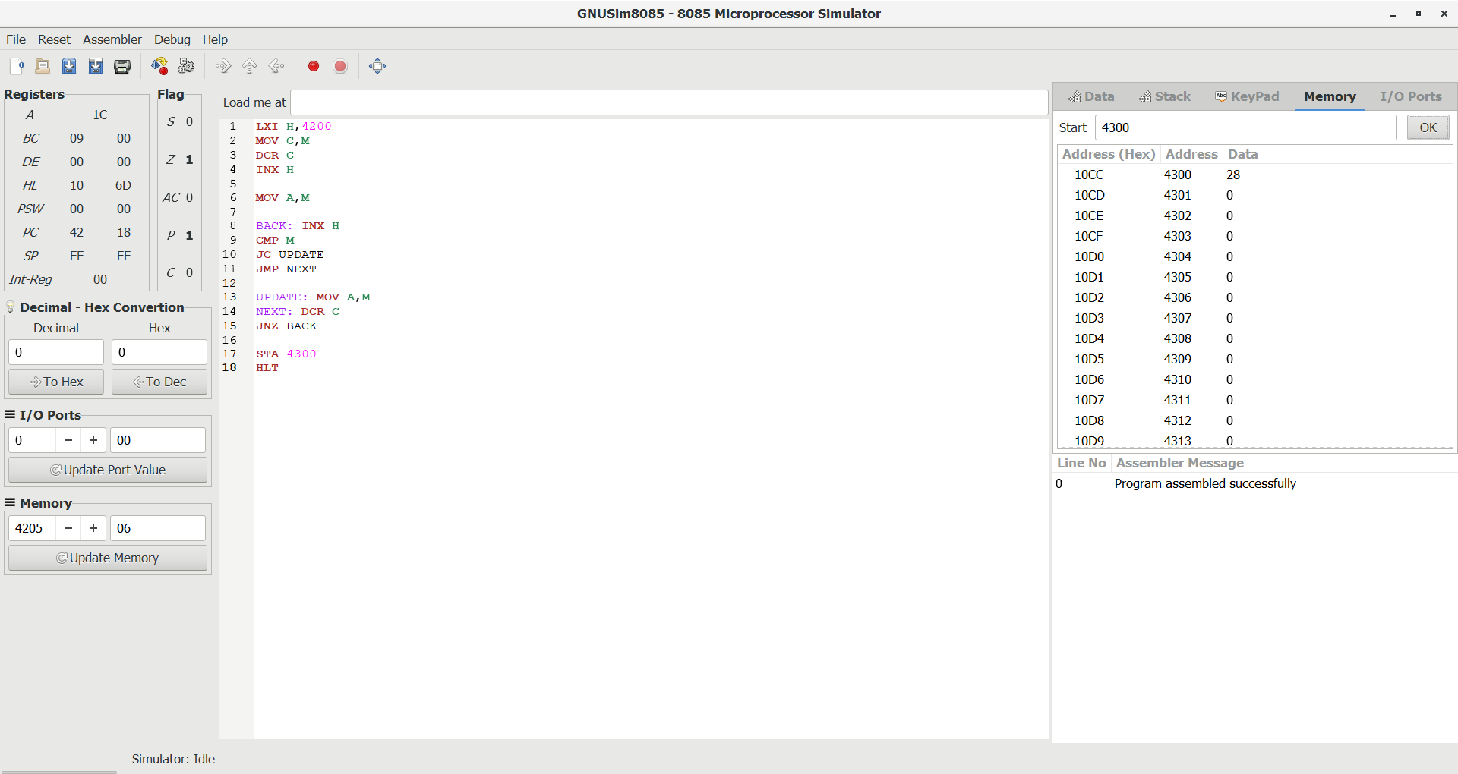

16.Write an assembly language program to find the Minimum number in an array.

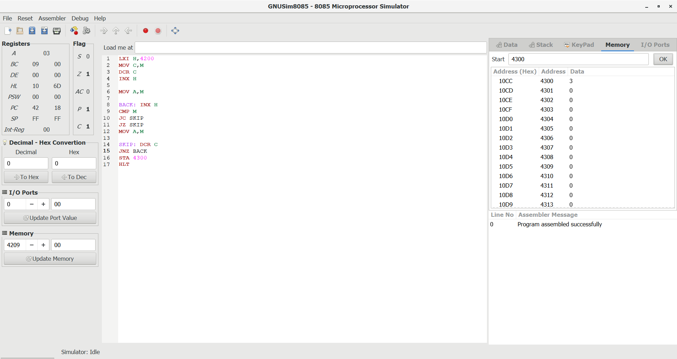

17.LCM of Two 8-bit Numbers using 8085
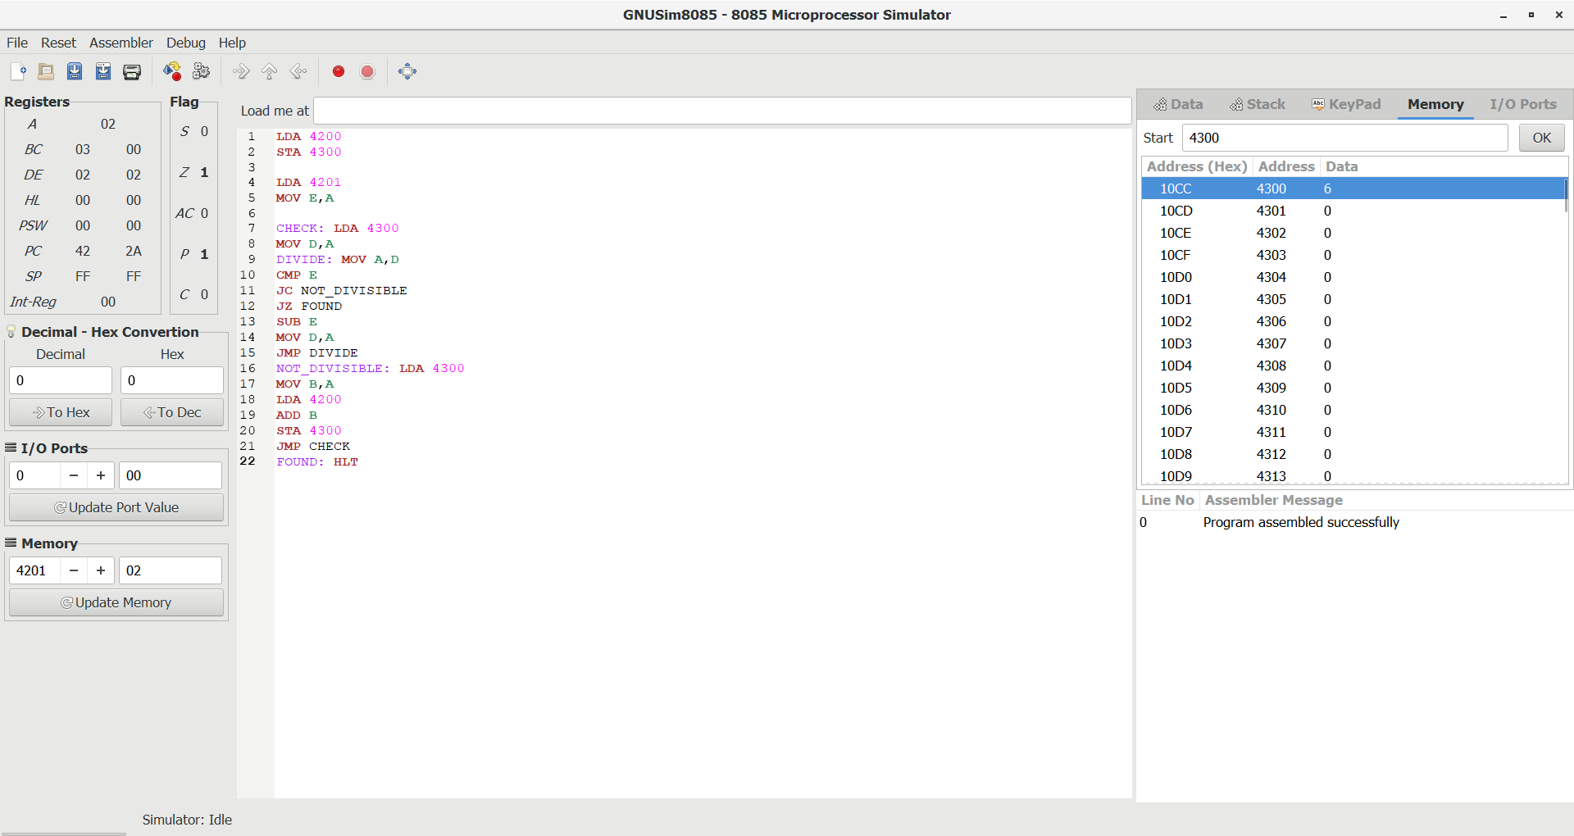

18.GCD of Two 8-bit Numbers using 8085
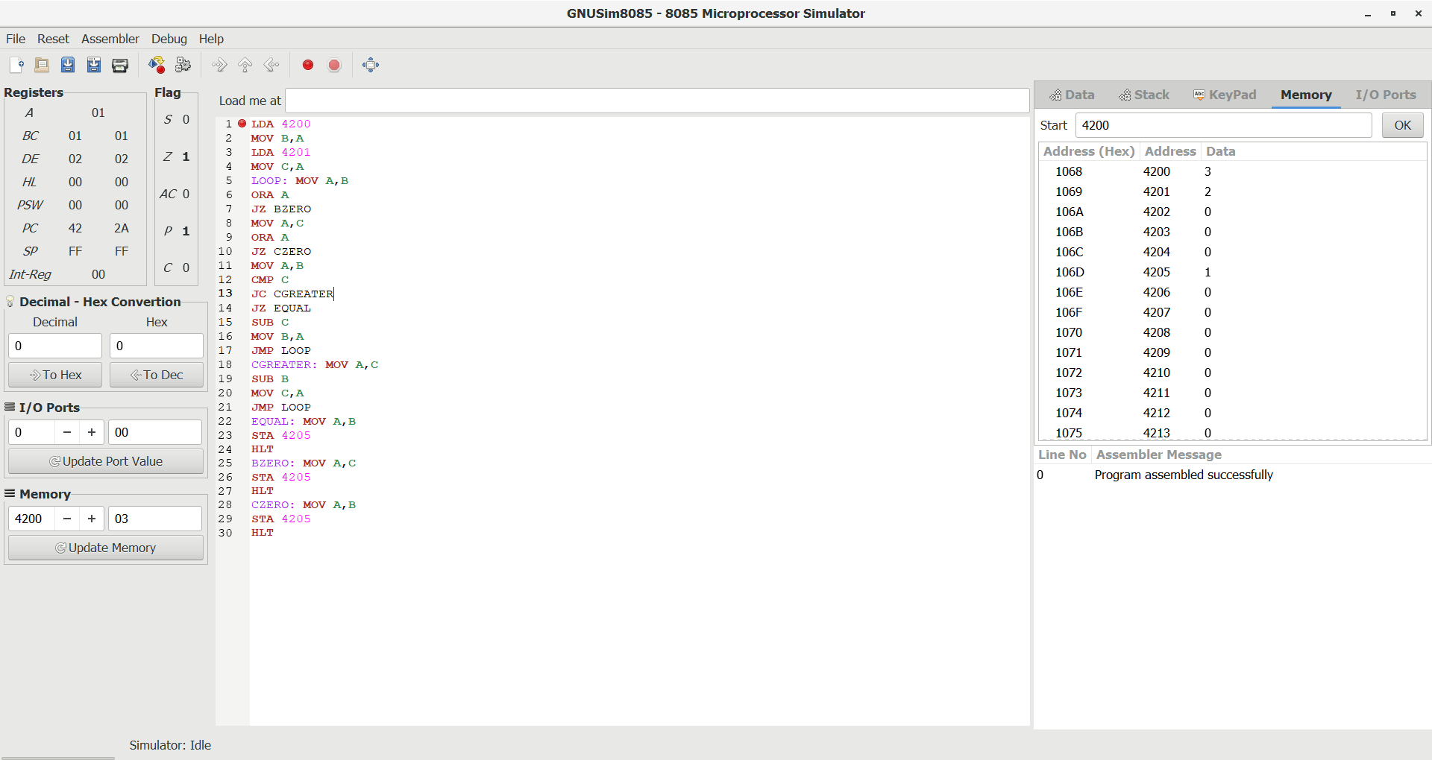

19.Factorial of an 8-bit Number using 8085
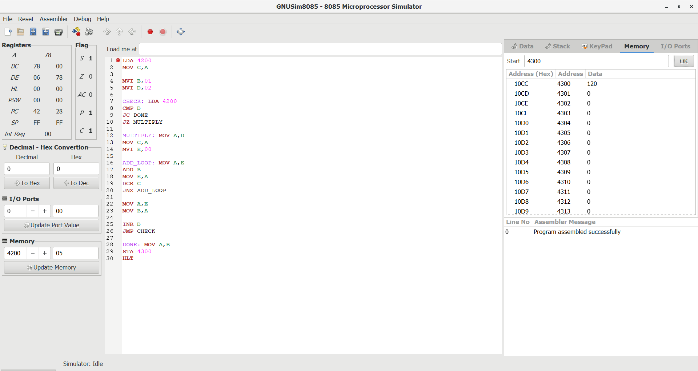

20.Convert decimal into hexadecimal
